Game and site project

­



**MADE BY:**

TheCoders

**REPOSITORY:**

TheCoders

Table of contents

**THECODERS** 1

TABLE OF CONTENTS 2

PROJECT IDEA 3

TEAM MEMBERS 3

STAGES OF THE PROJECT 4

PERFORMED TASKS 4

BLOCK DIAGRAM 5

FUTURE IDEAS 6

Project idea: Our purpose is to create a game and website for it

Team members

|  |  |  |  |
| --- | --- | --- | --- |
|  | **Name** | **Class** | **Role in the team** |
| **1.** | Yoan Hristiqnov Tanev | **10B** | **Scrum Trainer** |
| **2.** | Kiril Georgiev Dimitrov | **10B** | **Scrum Trainer** |
| **3.** | **Lubomir Rumenov Georgiev** | **9B** | **Backend developer** |
| **4.** | Ivan Dimchev Chelebiev | **9B** | **Backend developer** |
| **5.** | Steliyan Dimitrov Kehayov | **9B** | **Backend developer** |
| **6.** | Nikoleta Radostinova Ruseva | **8A** | **Frontend developer** |
| **7.** | **Teodor Dimitrov Tanev** | **8A** | **Frontend developer** |
| **8.** | **Filipa Haralambieva Popova** | **8A** | **Frontend developer** |

Stages of the project

PERFORMED TASKS **✔**

|  |  |
| --- | --- |
|  | Performed tasks |
| 1 | Created a home page where is the beginning of our project  It contains navigation bar, our logo and footer |
| 2 | Created a description of the game page  There we have a description of the rooms in the game. |
| 3 | Created about us page  This is the page where you can see the members of our team |
| 4 | Created contact us page  There the users can send their feedbacks and questions |
| 5 | Created download page  On this page there is one big button DOWNLOAD from which you can download our game |
| 6 | Create the projects README  In the README of our project you can see a brief description of our project |
| 7 | Last touches  We checked for mistakes and made final test of our components |

BLOCK DIAGRAM

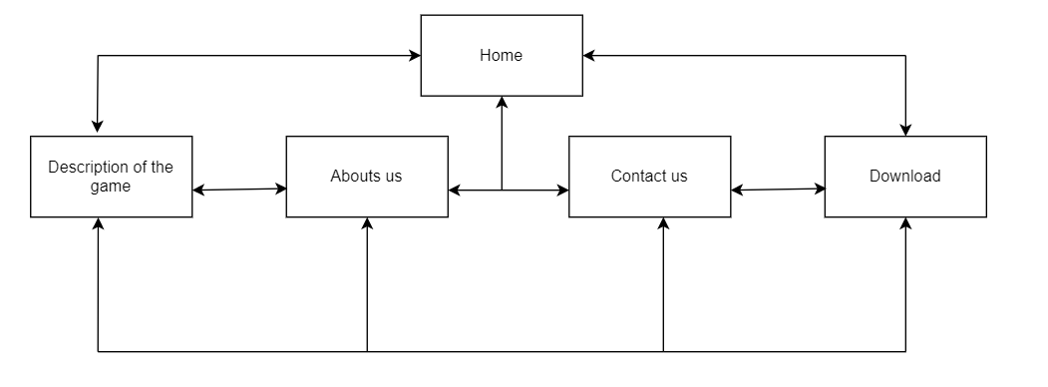

FUTURE IDEAS

|  |  |
| --- | --- |
|  |  |
| 1 | Create new stages |
| 2 | Create new characters |
| 3 | Option to save your progress |